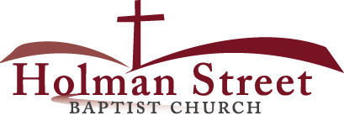

**“LET GOD’S VISION BE SEEN IN 2017”**

**THE IDENTIFICATIONS OF AN AUTHENTIC MOTHER**

**(What Does She Look Like?)**

Proverbs 31:10-31

.

1. The **authentic mother** can be recognized by **her working hands**; vv.13, 16, 19, 22, 24, 31
2. The **authentic mother** can be recognized by **her velvet voice**; v.26
3. The **authentic mother** can be recognized by **her watchful eyes**; v.27
4. The **authentic mother** can be recognized by **her caring heart**; vv.15, 18, 20,30
5. CONCLUSION: **THE MOUNTAINS vs THE MOTHER**

5.14.17