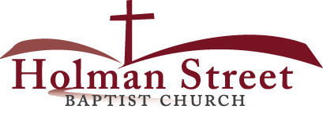

**“LET GOD’S VISION BE SEEN IN 2017”**

**THE HOLY SPIRIT**

Acts 1:1-8

**Bible Fact:** Jesus expects **all of His disciples** to demonstrate the power of **His kingdom** that He died and rose for.

**The Big Idea:** To get all Christians to **believe and to receive** power **to engage with God** to perform miraculous works that represent God and **so they can spread the good news all over the world.**

I. The **objectives** of the Holy Spirit dwelling in Christians:

A. The **4 Holy Spirit’s** objectives in every believer:

1. To exemplify His **person**

2. To experience His **power**

3. To elevate His **purpose**

4. To execute His **plan**

B. **The Holy Spirit: His Way, His Work And His Witness**

1. His **way** the best **way** for spiritual believers to set Christian standards among unbelievers;

a. His **way** is spiritual; Deuteronomy 6:4-18; 8:6,7, 10-20; Romans 8:8-16; II Corinthian 6:14-18

* God demands spiritual **CONTROL** among His people that He can bless them. (See the circles on the back page.)

b. His **way** is the best way (best **COMMUNION** results); Jeremiah 29:10-14; 31:33; John 10:10; 14:6

* His way leads to **a better peace**; Psalm 37:37; Isaiah 26:3,4
* His way leads to **a better promise**; Exodus 19:5; I Kings 8:56,57; Romans 4:13,14,16,20
* His way leads to **a better position**; Deuteronomy 28:13; John 15:1-8
* His way leads to **a better power**; Acts 1:8; Ephesians 1:17-23

5.23.17 Lesson 2

**THE HOLY SPIRIT CONTROL LIFE**

**(By Bill Bright: The four spiritual laws.)**

**These two circles represent two kinds of lives:**

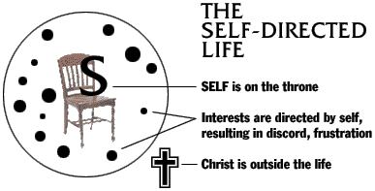

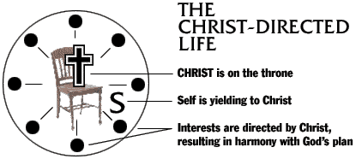

Which circle best represent your life?

Which circle would you like to have represent your life?