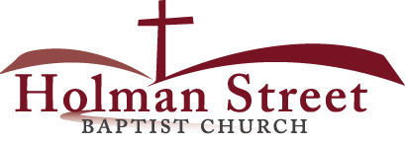

**“LET GOD’S VISION BE SEEN IN 2017”**

**THE HOLY SPIRIT**

Acts 1:1-8

**Bible Fact:** Jesus expects **all of His disciples** to demonstrate the power of **His kingdom** that He died and rose for.

**The Big Idea:** To get all Christians to **believe and to receive** power **to engage with God** to perform miraculous works that represent God and **so they can spread the good news all over the world.**

I. The **objectives** of the Holy Spirit dwelling in Christians:

A. The **4 Holy Spirit’s** objectives in every believer:

1. To exemplify His **person**

2. To experience His **power**

3. To elevate His **purpose**

4. To execute His **plan**

B. **The Holy Spirit: His Way, His Work And His Witness**

1. His **way,** the best **way** for spiritual believers to set **Christian standards** among unbelievers;

2. His **work**, the best **work** for demonstrating **spiritual change** that persuades unbelievers;

A. **Readiness** for the Holy Ghost’s work (**His will**)

B. **Power** of His work (**His will)**;

* **Power of His work (His will)** demonstrated as **the Christian movement**;
  + Luke, in his letter to Theophilus, throughout **The Book of The Acts of The Holy Spirit** follows the movement of the Church on its mission for Jesus Christ. It is a continuous movement marching towards eternity; Acts 1:1-3.
  + The Holy Spirit’s Church movement **on the move (from the time of the moment in Acts 2)**
    - The Holy Spirit’s **protection** of the Church’s **purpose**
    - The Holy Spirit’s **problem** solving among Church members; 6:1-7
      * In growth brings change and change brings challenges; v. 1; Matthew 28:19,20; Acts 1:8
      * The word of God vs. serving tables; v.2
      * Criteria for resolving Church challenges; v.3
      * Clear operational roles for the clergy; v.4
        + Not a neglect or exempt of administration role
      * The Holy chooses The Holy Seven; v.5
      * The Apostles give approbation for the chosen; v.6; 13:3; I Timothy 4:14; 5:22; II Timothy 6:1
      * The Church’s spiritual system for success; v.7
        + Word of God spread; Isaiah 55:11; Matthew 11:28,29; v.7a; Acts 12:24; 19:20
        + Christian discipleship grew; v7b; Acts 2:41,42; 9:31
        + Spiritual leaders were led the people under the voice of the Holy Ghost Who is the leader of the faith; v.7c

8.1.17 Lesson 10

**THE HOLY SPIRIT CONTROL LIFE**

**(By Bill Bright: The four spiritual laws.)**

**These two circles represent two kinds of lives:**

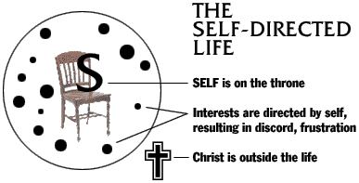

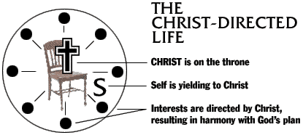

Which circle best represent your life?

Which circle would you like to have represent your life?