

**“LET GOD’S VISION BE SEEN IN 2017”**

**THE HOLY SPIRIT**

Acts 1:1-8

**Bible Fact:** Jesus expects **all of His disciples** to demonstrate the power of **His kingdom** that He died and rose for.

**The Big Idea:** To get all Christians to **believe and to receive** power **to engage with God** to perform miraculous works that represent God and **so they can spread the good news all over the world.**

I. The **objectives** of the Holy Spirit dwelling in Christians:

A. The **4 Holy Spirit’s** objectives in every believer:

1. To exemplify His **person**

2. To experience His **power**

3. To elevate His **purpose**

4. To execute His **plan**

B. **The Holy Spirit: His Way, His Work And His Witness**

1. His **way,** the best **way** for spiritual believers to set **Christian standards** among unbelievers;

2. His **work**, the best **work** for demonstrating **spiritual change** that persuades unbelievers;

A. **Readiness** for the Holy Ghost’s work (**His will**)

B. **Power** of His work (**His will)**;

* **Power of His work (His will)** demonstrated as **the Christian movement**;
  + Luke, in his letter to Theophilus, throughout **The Book of The Acts of The Holy Spirit** follows the movement of the Church on its mission for Jesus Christ. It is a continuous movement marching towards eternity; Acts 1:1-3.
  + The Holy Spirit’s Church movement **on the move (from the time of the moment in Acts 2)**
    - The Holy Spirit’s **protection** of the Church’s **purpose**
    - The Holy Spirit’s **problem** solving among Church members;
    - The Holy Spirit’s **power** for opposition against the Church; Matthew 16:18; Acts 6:8-60
      * Because of the Holy Ghost Stephen **did supernatural work** for the Church; vv.8,9
      * Stephen’s power through the Holy Ghost **overpowered** his enemies; Exodus 4:12; Isaiah 54:17; Proverbs 2:6; Luke 21:12-16; Acts 5:39; **6:10**
      * Enemies lied against the Holy Ghost within Stephen to **overthrow t**he work; vv.11-15
      * Stephen’s sermon broke their hearts and stirred up wrath; Acts 7:2-53 (52 verses of Bible truth)
      * The truth is hard to take but the message worth dying for;
        + Evil men rejected the truth; v.54
        + Stephens’s looked at the glory of the Lord in heaven; vv.55,56
        + They killed the messenger but did not stop the message; vv. 57-60

8.8.17 Lesson 11

**THE HOLY SPIRIT CONTROL LIFE**

**(By Bill Bright: The four spiritual laws.)**

**These two circles represent two kinds of lives:**

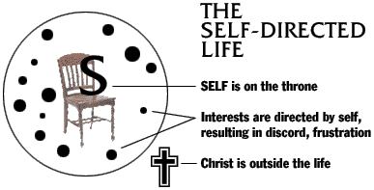

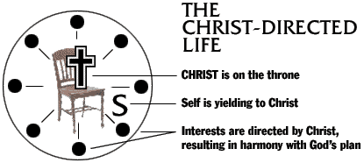

Which circle best represent your life?

Which circle would you like to have represent your life?