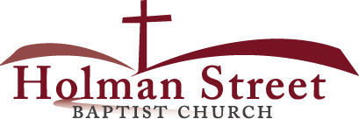

**“LET GOD’S VISION BE SEEN IN 2017**

8.13.17

**My Harvest Time**

**(God wants me to have a great harvest time.)**

Ezekiel 36:1-11

**“Miracles are things that happen that only God can do” …God still does miracles among His people!**

In Chapter 36:1-38, Ezekiel, the prophet of God, announces that God is ready to give them a new harvest for their lives. God requested that Ezekiel make this announcement to the mountains, hills, rivers and valleys of Israel. In other words, God wanted Ezekiel to get the word out that HELP is on the way for their HOPE. Many had been hoping that God would turn things around and make things better. All they had left was HOPE and they needed HELP. In a land of desolation and isolation all they had left was HOPE. Based upon Israel’s HOPE alone God was ready to do miraculous things for His people in the midst of their hopelessness: **TO GIVE THEM A HARVEST TIME AGAIN!**

**What God wants to do for your harvest:**

1. **Renew** your heart and purify your living; vv. 26,27,31
2. **Regroup** your faith from fainting moments; v. 29
3. **Reduce** your shame among the heathens; v. 24
4. **Redirect** your resources in your favor; v. 30
5. **Reschedule** your delays; v. 34
6. **Replenish** your fields like the Garden of Eden; v. 35
7. **Resurrect** and regain the fame of **His Holy Name**; vv. 21-23, 38

* **JEHOVAH-JIREH:**"The Lord Will Provide
* **JEHOVAH-ROPHA:**"The Lord Who Heals"
* **JEHOVAH-NISSI:**"The Lord Our Banner."
* **JEHOVAH-M'KADDESH:**"The Lord Who Sanctifies"
* **JEHOVAH-SHALOM:**"The Lord Our Peace"
* **JEHOVAH-TSIDKENU**"The Lord Our Righteousness"
* **JEHOVAH-ROHI:**"The Lord Our Shepherd"
* **JEHOVAH-SHAMMAH:**"The Lord is There"
* **JEHOVAH-SABAOTH:** "The Lord of Hosts"