

**“LET GOD’S VISION BE SEEN IN 2017”**

**THE HOLY SPIRIT**

Acts 1:1-8

**Bible Fact:** Jesus expects **all of His disciples** to demonstrate the power of **His kingdom** that He died and rose for.

**The Big Idea:** To get all Christians to **believe and to receive** power **to engage with God** to perform miraculous works that represent God and **so they can spread the good news all over the world.**

I. The **objectives** of the Holy Spirit dwelling in Christians:

A. The **4 Holy Spirit’s** objectives in every believer:

1. To exemplify His **person**

2. To experience His **power**

3. To elevate His **purpose**

4. To execute His **plan**

B. **The Holy Spirit: His Way, His Work And His Witness**

1. His **way,** the best **way** for spiritual believers to set **Christian standards** among unbelievers;

2. His **work**, the best **work** for demonstrating **spiritual change** that **persuades unbelievers**;

a. **Readiness** for the Holy Ghost’s work (**His will**)

b. **Power** of His work (**His will)**;

**He Did Not Come Alone**

**Dr. A. J. Gordon tells of a Welsh preacher who, having been scheduled to preach one night, asked to be allowed to withdraw for a time before the service. He remained in seclusion so long that the good man of the house sent his servant to request him to come and meet the waiting congregation. As she came near the room she heard what seemed to be an indication of conversation between two parties, and though in subdued tone of voice, she caught the words, "I will not go unless You go with me." Without interfering, she returned and reported, "He will come all right, and the Other will come, too." And sure enough, when he came, the Other One came along, and with such power that it proved a wonderful service in which many found newness of life. It is both our privilege and duty thus to allow the Holy Spirit to work along with us as we endeavor to teach others about the Lord Jesus Christ.*—Christian Union Herald.***

c.. Power of His work (**His will**) to **SEEK AND SAVE THE LOST (**Luke 19:9,10**)**

1. Salvation and the human change; Galatians 1:3-18; 2:20

* What happens when people are saved by grace through faith to Christ? (Ephesians 2:8-10)
  + The **MIND** is illuminated; (conversion) Philippians 2:5
  + The **HEART** is motivated; (conviction) Romans 10:10
  + The **WILL** is captivated; (commitment); Psalm 31:5

d. The roles of the Holy Ghost in Jesus:*

* Salvation = preservation
* Demonstration = power
* Orchestration = participation
* Revelation = picture
* Coordination = punctuation
* Administration = process
* Proclamation = pronouncement

1. The Holy Ghost helps Saul with his **first sermon**; vv.20-22
2. The Holy Ghost gives Saul an escape plan; vv.23-25
3. The Holy Ghost connects Saul to Barnabas; vv.26-30
4. The Holy Ghost makes for peace by the call of Saul; v.31
5. The Holy Ghost and Peter working in Lydda; vv.32-35
6. The Holy Ghost and Peter working in Joppa; vv.36-43
7. The Holy Ghost visits a vision; Acts 10:1-4
8. The Holy Ghost coordinates visions; vv..5-8
9. The Holy Ghost visits Peter:

* He **counsels** Peter from heaven; vv.9-11
* He **convicts** Peter about God’s will; vv.12-15
* He **convinces** Peter to do God’s will; vv.16-23
* He **connects** Peter with Cornelius; vv.24-26
* He **communicates** understanding between Peter and Cornelius; vv.27-33
* He **comforts** the house of people with the Gospel; vv.34-43
* He **commits** the house of people to enroll in the kingdom; vv.44-48

10.31.2017 Lesson 21

**THE HOLY SPIRIT CONTROL LIFE**

**(By Bill Bright: The four spiritual laws.)**

**These two circles represent two kinds of lives:**

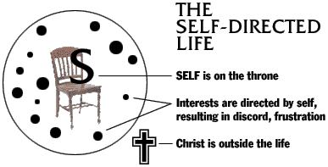 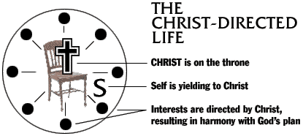

Which circle best represent your life? Which circle would you like to have represent your life?