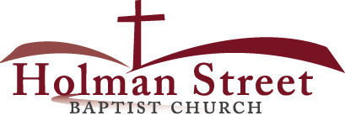

**“LET GOD’S VISION BE SEEN IN 2017”**

**THE HOLY SPIRIT**

Acts 1:1-8

**Bible Fact:** Jesus expects **all of His disciples** to demonstrate the power of **His kingdom** that He died and rose for.

**The Big Idea:** To get all Christians to **believe and to receive** power **to engage with God** to perform miraculous works that represent God and **so they can spread the good news all over the world.**

I. The **objectives** of the Holy Spirit dwelling in Christians:

A. The **4 Holy Spirit’s** objectives in every believer:

1. To exemplify His **person**

2. To experience His **power**

3. To elevate His **purpose**

4. To execute His **plan**

B. **The Holy Spirit: His Way, His Work And His Witness**

1. His **way,** the best **way** for spiritual believers to set **Christian standards** among unbelievers;

2. His **work**, the best **work** for demonstrating **spiritual change** that **persuades unbelievers**;

a. **Readiness** for the Holy Ghost’s work (**His will**)

b. **Power** of His work (**His will)**;

**Several learned men tried to persuade a great scholar to believe in Christianity, but all their efforts were in vain. A plain, uneducated person referred not so much to logical reasoning as to the work of the Holy Spirit; and the scholar exclaimed, "When I heard no more than human reason, I opposed it with human reason; but when I heard the Spirit I was obliged to surrender." Thus it is that, trusting to their own wisdom, the wisest are lost; while those who are taught of the Spirit know the way of God in truth.—*Buck***

c.. Power of His work (**His will**) to **SEEK AND SAVE THE LOST (**Luke 19:9,10**)**

1. Salvation and the human change; Galatians 1:3-18; 2:20

* What happens when people are saved by grace through faith to Christ? Ephesians 2:8-10)
  + The **MIND** is illuminated; (conversion) Philippians 2:5
  + The **HEART** is motivated; (conviction) Romans 10:10
  + The **WILL** is captivated; (commitment); Psalm 31:5

1. The Holy Ghost **seeking** Saul; Acts 9

d. The roles of the Holy Ghost in Jesus:*

* Salvation = preservation
* Demonstration = power
* Orchestration = participation
* Revelation = picture
* Coordination = punctuation
* Administration = process
* Proclamation = pronouncement

1. The Holy Ghost helps Saul with his **first sermon**; vv.20-22
2. The Holy Ghost gives Saul an escape plan; vv.23-25
3. The Holy Ghost connects Saul to Barnabas; vv.26-30
4. The Holy Ghost makes for peace by the call of Saul; v.31
5. The Holy Ghost and Peter working in Lydda; vv.32-35
6. The Holy Ghost and Peter working in Joppa; vv.36-43
7. The Holy Ghost visits a vision; Acts 10:1-4
8. The Holy Ghost coordinates visions; vv.5-8
9. Peter’s **appetite** and God’s **menu**; vv.9-16; II Corinthians 5:17

* The Holy Spirit **changes** old beliefs and human prejudices
* Through a **spiritual vertical connection** God persuaded Peer to change.

1. The Holy Spirit in **orchestration**; vv.17-33

* The Holy Spirit worked **two visions** for the same outcome in both Peter and in Cornelius **simultaneous confessions** (homologeo)

1. Peter preaches **the official Gospel to Cornelius** and his house; vv.34-43
2. The Holy Spirit **confirms the Gospel** preached by Peter to those who heard the word; vv.44-48

11.7.17 Lesson 22

**THE HOLY SPIRIT CONTROL LIFE**

**(By Bill Bright: The four spiritual laws.)**

**These two circles represent two kinds of lives:**

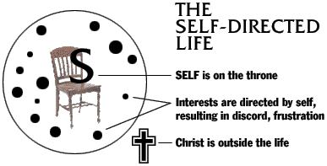 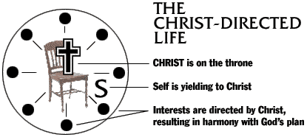

Which circle best represent your life? Which circle would you like to have represent your life?