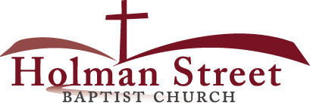

**“LET GOD’S VISION BE SEEN IN 2017”**

**THE HOLY SPIRIT**

Acts 1:1-8

**Bible Fact:** Jesus expects **all of His disciples** to demonstrate the power of **His kingdom** that He died and rose for.

**The Big Idea:** To get all Christians to **believe and to receive** power **to engage with God** to perform miraculous works that represent God and **so they can spread the good news all over the world.**

I. The **objectives** of the Holy Spirit dwelling in Christians:

A. The **4 Holy Spirit’s** objectives in every believer:

1. To exemplify His **person**

2. To experience His **power**

3. To elevate His **purpose**

4. To execute His **plan**

B. **The Holy Spirit: His Way, His Work And His Witness**

2. His **work**, the best **work** for demonstrating **spiritual change** that **persuades unbelievers**;

a. **Readiness** for the Holy Ghost’s work (**His will**)

b. **Power** of His work (**His will)**;

c.. Power of His work (**His will**) to **SEEK AND SAVE THE LOST (**Luke 19:9,10**)**

1. Salvation and the human change; Galatians 1:3-18; 2:20

* What happens when people are saved by grace through faith to Christ? Ephesians 2:8-10)
  + The **MIND** is illuminated; (conversion) Philippians 2:5
  + The **HEART** is motivated; (conviction) Romans 10:10
  + The **WILL** is captivated; (commitment); Psalm 31:5

1. The Holy Ghost **seeking** Saul; Acts 9

d. The roles of the Holy Ghost in Jesus:*

* Salvation = preservation
* Demonstration = power
* Orchestration = participation
* Revelation = picture
* Coordination = punctuation
* Administration = process
* Proclamation = pronouncement

1. Peter’s **appetite** and God’s **menu**; vv.9-16; II Corinthians 5:17
2. The Holy Spirit in **orchestration**; vv.17-33
3. The Holy Spirit **confirms the Gospel** preached by Peter to those who **heard the word;** vv.44-48
4. **Reflections** on how God changes people and changes things: Acts 11

* Tradition attacks Peter about changes made by God; vv.1-3
* Peter **rehearses** his testimony to his attackers; vv.4-15
* Peter **remembers** the words of Jesus; v.16; Isaiah 44:3; Matthew 3:11
* Peter’s testimony convinced the apostles to obey the Great Commission; vv.17,18
* The influence of Peter’s testimony that motivated the course of the movement of the Christian Church; vv.19-21
* Barnabas a brave bold brother for the Christian movement gives his leadership; vv. 22-26
* An act of God **creates a mission** for **the movement** in the hand of bold men with spiritual purpose; vv.27-30

11.28.17 Lesson 25

**THE HOLY SPIRIT CONTROL LIFE**

**(By Bill Bright: The four spiritual laws.)**

**These two circles represent two kinds of lives:**

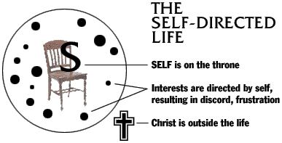 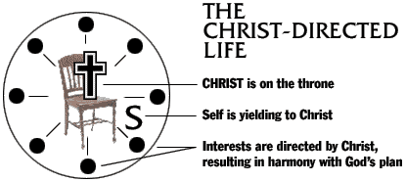

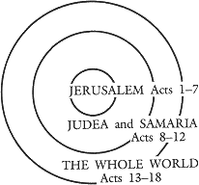Which circle best represent your life? Which circle would you like to have represent your life?