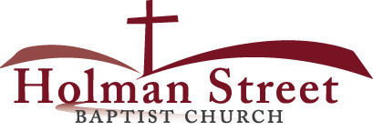

**“LET GOD’S VISION BE SEEN IN 2017”**

12.31.17

WHERE ARE YOU GOING NEXT YEAR?

Hebrews 11:8-10

Do you know how you will today get to where you are going tomorrow? Do you think you already know which way you are going next year to achieve your maximum Divine purpose? If you say that you already know where you are going next year today **you really don’t know**. Abraham tells those who are looking for a sure foundation or solid course for success next year just how to find **what they do not know** or what they are looking for.

1. Chose **the way of faith** to get through next year successfully; v.8a (by faith…)
2. Accept your **assignment of success** from God that will give you valuable returns for your prosperity and your posterity; v.8b
3. By your actions **do not** argue with God and **His assignments** for you. v.8c
4. Move and trust God even **when you don’t know** where you are going; v.8d; Psalm 37:23
5. Believe that God’s **promise** for you will prosper **wherever** He sends you on earth or in heaven; vv.9,10; Romans 4:20
6. **CONCLUSION:** YOU DON’T NEED TO KNOW ABOUT TOMORROW BUT YOU DO NEED TO KNOW WHO’S HOLDING YOUR HAND.