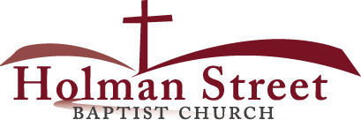

**“JOIN GOD’S TEAM IN 2018”**

1.7.18

**CHRISTIAN COMPLIANCE TO AUTHORITY**

**Romans 13:1-8**

I. **Introduction**

**God made Christians to be compliant people**. Christians have a manual to live by, the Bible. We have a compliance officer and a compliance office. The pastor/preacher is the compliance officer that God put in charge of His business and His people. The Holy Spirit is the compliance office. Other Christian Church leaders in the Christian Church help to make up the compliance team. Church leaders are God’s compliance TEAM.

II. **The Word Authority**

Authority in the Greek is the word ***exousia***.

A. It means the right to exercise power

B. It means the rule or governing power

III. **Several Basic Powers In The Early Church Days**

A. Apostolic power

B. Power of judicial decision

C. Power of managing domestic affairs

IV. **The Need for Authority**

A. Because of sin; Genesis 3:16,17; I Tim. 1:9

B. Because of diversity I Corinthians 12:4-14

V. **Christian Compliance Bible Rules or Bible Facts:**

A. Christian compliance is a volunteer act. v.1a

1. God expects Christians to comply and respect

all leaders.

2. All offices of authority are upheld by God.

B. God made all powers to exist; v.1b

C. God's power is above all other powers. v.1c

D. Resisting powers is rebellion against God. v.2;

Numbers 12:1-5,9,10

1. **Note that consequences always follow resistance to any rules.**

E. Persons that are given authority are expect by God to

do good and fight against evil. v.3

F. God gives those in authority the power and judgement

to condemn. v.4

G. Compliance to authority says a lot about ones mental

state of thinking and attitude. v.5

H. God expects Christians to regard and obey the laws of the land. vv.6,7

I. **God rewards** those who come into agreement or compliance

with His ways and commands. Hebrews 13:7,17

.Proverbs 16:7

.Matthew 5:6

.Psalm 119:11

.Psalm 119:130

.Psalm 119:165

.Psalm 1:1-3