

**“JOIN GOD’S TEAM IN 2018”**

**THE HOLY SPIRIT**

Acts 1:1-8

**Bible Fact:** Jesus expects **all of His disciples** to demonstrate the power of **His kingdom** that He died and rose for.

**The Big Idea:** To get all Christians to **believe and to receive** power **to engage with God** to perform miraculous works that represent God and **so they can spread the good news all over the world.**

I. The **objectives** of the Holy Spirit dwelling in Christians:

A. The **4 Holy Spirit’s** objectives in every believer:

1. To exemplify His **person**

2. To experience His **power**

3. To elevate His **purpose**

4. To execute His **plan**

B. **The Holy Spirit: His Way, His Work And His Witness**

2. His **work**, the best **work** for demonstrating **spiritual change** that **persuades unbelievers**;

a. **Readiness** for the Holy Ghost’s work (**His will**)

b. **Power** of His work (**His will)**;

c.. Power of His work (**His will**) to **SEEK AND SAVE THE LOST (**Luke 19:9,10**)**

1. Salvation and the human change; Galatians 1:3-18; 2:20

* What happens when people are saved by grace through faith to Christ? Ephesians 2:8-10)
  + The **MIND** is illuminated; (conversion) Philippians 2:5
  + The **HEART** is motivated; (conviction) Romans 10:10
  + The **WILL** is captivated; (commitment); Psalm 31:5

1. The Holy Ghost **seeking** Saul; Acts 9

d. The roles of the Holy Ghost of Jesus in ministry:*

* Salvation = preservation
* Demonstration = power
* Orchestration = participation
* Revelation = pictorial
* Coordination = punctuation
* Administration = process
* Proclamation = pronouncement

e. The power of the Holy Spirit in His **demonstration**; Acts 12

f. The power of the Holy Spirit in His **coordination and orchestration** of the mission; Acts 13

1. The Holy Spirit **mobilizing the mission** of the Christian Church; vv.1,2

2. The ordination before participation; v.3

3. Taking good news to bad areas; vv.4,5

4. An invitation to hear the Gospel; vv.6,7

5. The Gospel is **challenged** by an unbeliever; vv. 8-11

6. The Gospel **changes** those that believe; v.12

7. The preparedness of Paul to preach and persuade people to God; vv.13-15

A. Outline of Paul’s Jewish message, his subject: Men that fear God;

v.16

1. Israel was a strangers in Egypt; v.17

2. Forty years in the wilderness; v.18

3. Canaan land and the inheritance; v.19

4. God gave Israel judges for 450 years up to Samuel; v.20

5. God gave the people their desire of Saul as a king; v.21

6. God raised up David as His king; v.22

7. God gave Jesus as the promised seed of David; v.23

8. John the Baptist the forerunner to Jesus; vv.24,25

9. As children of Abraham do you fear God; v.26

10. The Gospel of Jesus; vv.27-31

11. Jesus is God’s promise; vv.32,33

12. In Jesus is NO corruption; vv.34-37

13: Jesus came to forgive sins; vv.38,39

14. A caution of unbelief; vv.40,41

15. The power of Paul’s preaching Jesus; vv.42-44

16. Paul defends the faith and the Gospel; vv.45-48

17. Persecution sponsors the publishing of more Gospel; vv.49-

52

2.12.18 Lesson 28

**THE HOLY SPIRIT CONTROL LIFE**

**(By Bill Bright: The four spiritual laws.)**

**These two circles represent two kinds of lives:**

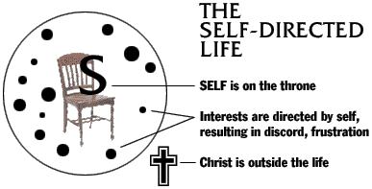 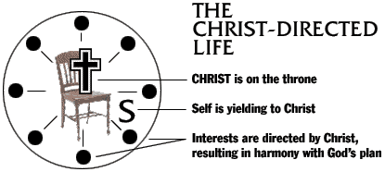

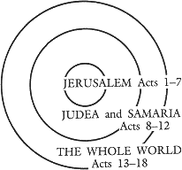Which circle best represent your life? Which circle would you like to have represent your life?