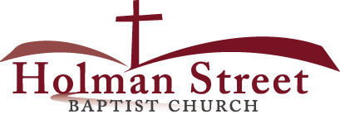

**“JOIN GOD’S TEAM IN 2018”**

**THE HOLY SPIRIT**

Acts 1:1-8

**Bible Fact:** Jesus expects **all of His disciples** to demonstrate the power of **His kingdom** that He died and rose for.

**The Big Idea:** To get all Christians to **believe and to receive** power **to engage with God** to perform miraculous works that represent God and **so they can spread the good news all over the world.**

I. The **objectives** of the Holy Spirit dwelling in Christians:

A. The **4 Holy Spirit’s** objectives in every believer:

1. To exemplify His **person**

2. To experience His **power**

3. To elevate His **purpose**

4. To execute His **plan**

B. **The Holy Spirit: His Way, His Work And His Witness**

c.. Power of His work (**His will**) to **SEEK AND SAVE THE LOST (**Luke 19:9,10**)**

1. Salvation and the human change; Galatians 1:3-18; 2:20

* What happens when people are saved by grace through faith to Christ? Ephesians 2:8-10)
  + The **MIND** is illuminated; (conversion) Philippians 2:5
  + The **HEART** is motivated; (conviction) Romans 10:10
  + The **WILL** is captivated; (commitment); Psalm 31:5

1. The Holy Ghost **seeking** Saul; Acts 9

d. The roles of the Holy Ghost of Jesus in ministry:*

* Salvation = preservation
* Demonstration = power
* Orchestration = participation
* Revelation = pictorial or portrait
* Coordination = punctuation
* Administration = process
* Proclamation = pronouncement

e. The power of the Holy Spirit in His **demonstration**; **Acts 12**

f. The power of the Holy Spirit in His **coordination and orchestration** of the mission; **Acts 13**

g. The Gospel on the go by **proclamation** and **administration**; **Acts 14**

h. The Gospel on the go by **administration** and **coordination**; **Acts 15**

i.The Gospel on the go under **orchestration, punctuation and demonstration** ;  **Acts 16**

1. The Holy Spirit leads Paul to Timothy; v.1

* Timothy was **ministry-ready** and highly recommended; v.2

1. Paul prepares and mentors Timothy for Christian ministry; v.3

* I Timothy 1:2,3; 4:12,13

1. Paul and his Christian team provides spiritual administration to other Christians; vv.4,5
2. Paul and his team obeying the WILL OF GOD and the guide of The Holy Spirit; vv.6,7

* Note: Following The Holy Spirit requires spiritually MATURE discipline or spiritual RESPECT, firm leadership and obedient followship.

1. Paul under **mature** **intense spiritual development (MISD)** of The Holy Spirit; vv.8-10; Psalm 37:23

* **Holy Serendipity**: "finding something when looking for something else, thanks to an observant mind" (Marian Webster Dictionary)
* **Divine Providence**: God ties everything in the universe to His will, good or bad; He directs and redirects courses of history and event.
  + God is the Sovereign Superintendent of all of time and all of His creation.
  + TRUST is a MUST to demonstrate CHRISTIAN MATURITY. To trust means to accept and live with WHATEVER HAPPPENS because God KNOWS all things before things happen and after they happen, God knows what is next.
  + God puts The Holy Spirit in charge to make God’s will happen regardless of status, resources, abilities, timing. Romans 8:28; Psalm 23:1; Jeremiah 29:11; Jeremiah 40:31; Genesis 50:20
    - There are NO misstates with God.
    - Accept His will and live with it for the outcome.

1. Paul’s MISD and his obedience to follow God’s intent by The Holy Spirit gets him to the ministry at Philippi; vv.11,12

3.27.18 Lesson 34

**THE HOLY SPIRIT CONTROL LIFE**

**(By Bill Bright: The four spiritual laws.)**

**These two circles represent two kinds of lives:**

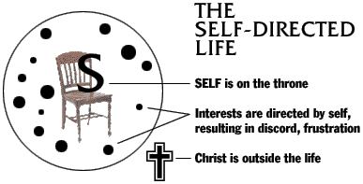 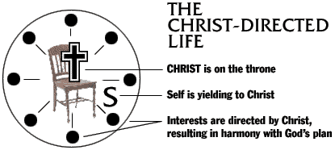

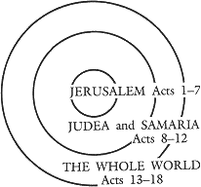Which circle best represent your life? Which circle would you like to have represent your life?