

**“JOIN GOD’S TEAM IN 2018”**

**THE HOLY SPIRIT**

Acts 1:1-8

**Bible Fact:** Jesus expects **all of His disciples** to demonstrate the power of **His kingdom** that He died and rose for.

**The Big Idea:** To get all Christians to **believe and to receive** power **to engage with God** to perform miraculous works that represent God and **so they can spread the good news all over the world.**

I. The **objectives** of the Holy Spirit dwelling in Christians:

A. The **4 Holy Spirit’s** objectives in every believer:

1. To exemplify His **person**

2. To experience His **power**

3. To elevate His **purpose**

4. To execute His **plan**

B. **The Holy Spirit: His Way, His Work And His Witness**

c.. Power of His work (**His will**) to **SEEK AND SAVE THE LOST (**Luke 19:9,10**)**

1. Salvation and the human change; Galatians 1:3-18; 2:20

* What happens when people are saved by grace through faith to Christ? Ephesians 2:8-10)
  + The **MIND** is illuminated; (conversion) Philippians 2:5
  + The **HEART** is motivated; (conviction) Romans 10:10
  + The **WILL** is captivated; (commitment); Psalm 31:5

1. The Holy Ghost **seeking** Saul; Acts 9

d. The roles of the Holy Ghost of Jesus in ministry:*

* Salvation = preservation
* Demonstration = power
* Orchestration = participation
* Revelation = portrait
* Coordination = punctuation
* Administration = process
* Proclamation = pronouncement

e. The power of the Holy Spirit in His **demonstration**; **Acts 12**

f. The power of the Holy Spirit in His **coordination and orchestration** of the mission; **Acts 13**

g. The Gospel on the go by **proclamation** and **administration**; **Acts 14**

h. The Gospel on the go by **administration** and **coordination**; **Acts 15**

i.The Gospel on the go under **orchestration, punctuation and demonstration** ;  **Acts 16**

1. The stalking of Paul by the possessed to expose the power he had; vv.16-18

1. The providence and persecution of Paul’s preaching; vv.19-22
2. The providence witness of Paul’s prison ministry; vv.23,24
3. The anointed witness that brings effective power; vv.25-29
4. The Christian witness should become power to persuade others; Acts 1:8
5. The end result of the Christian’s witness; vv.30-32
6. Salvation DEMANDS DEMONSTRATION; vv.33,34
7. Christianity DEMANDS RESPECT; vv.35-40

k. The Gospel on the go by **proclamation and demonstration**. Acts 17

1. Paul preached Jesus and His resurrection to Jews; vv.1-3

2. Some believed and some did not and rioted against the Gospel influence; vv.4-9 3. The Gospel better received at Berea; vv.10-12

4. The Gospel challenged by unbelievers; vv.13-15

5. Paul defends the Gospel in Athens; vv.16-18

6. Paul paraded before philosophers and their high court; vv.19-21

7. Paul’s apology sermon; vv.22-31

8. Some laugh at Paul’s sermon while others believed; vv.32-34

4.24.18 Lesson 37

**THE HOLY SPIRIT CONTROL LIFE**

**(By Bill Bright: The four spiritual laws.)**

**These two circles represent two kinds of lives:**

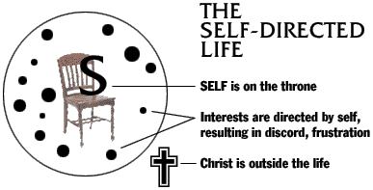 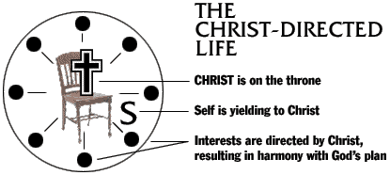

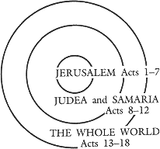Which circle best represent your life? Which circle would you like to have represent your life?