

**“JOIN GOD’S TEAM IN 2018”**

**THE HOLY SPIRIT**

Acts 1:1-8

**Bible Fact:** Jesus expects **all of His disciples** to demonstrate the power of **His kingdom** that He died and rose for.

**The Big Idea:** To get all Christians to **believe and to receive** power **to engage with God** to perform miraculous works that represent God and **so they can spread the good news all over the world.**

I. The **objectives** of the Holy Spirit dwelling in Christians:

A. The **4 Holy Spirit’s** objectives in every believer:

1. To exemplify His **person**

2. To experience His **power**

3. To elevate His **purpose**

4. To execute His **plan**

B. **The Holy Spirit: His Way, His Work And His Witness**

c.. Power of His work (**His will**) to **SEEK AND SAVE THE LOST (**Luke 19:9,10**)**

1. Salvation and the human change; Galatians 1:3-18; 2:20

* What happens when people are saved by grace through faith to Christ? Ephesians 2:8-10)
  + The **MIND** is illuminated; (conversion) Philippians 2:5
  + The **HEART** is motivated; (conviction) Romans 10:10
  + The **WILL** is captivated; (commitment); Psalm 31:5

1. The Holy Ghost **seeking** Saul; Acts 9

d. The roles of the Holy Ghost of Jesus in ministry:*

* Salvation = preservation
* Demonstration = power
* Orchestration = participation
* Revelation = portrait
* Coordination = punctuation
* Administration = process
* Proclamation = pronouncement

e. The power of the Holy Spirit in His **demonstration**; **Acts 12**

f. The power of the Holy Spirit in His **coordination and orchestration** of the mission; **Acts 13**

g. The Gospel on the go by **proclamation** and **administration**; **Acts 14**

h. The Gospel on the go by **administration** and **coordination**; **Acts 15**

i.The Gospel on the go under **orchestration, punctuation and demonstration** ;  **Acts 16**

k. The Gospel on the go by **proclamation and demonstration**. **Acts 17**

1. Paul preached Jesus and His resurrection to Jews; vv.1-3

2. Some believed and some did not and rioted against the Gospel

influence; vv.4-9

3. The Gospel better received at Berea; vv.10-12

4. The Gospel challenged by unbelievers; vv.13-15

5. Paul defends the Gospel in Athens; vv.16-18

* Athens is a place of idolatry (a reason for the Gospel); v.16
* Paul held sessions with Jew to teach the Gospel; v.17
* Paul criticized by philosophers and called his preaching Jesus babbling; v.18

6. Paul paraded before philosophical thinkers and their high court; vv.19-21

* They requested to hear Paul defend his new strange doctrine; vv.19-21

7. Paul’s apologetic sermon to defended Christ at Athens; vv.22-31

* Paul challenges Athens with what they DO NOT know; vv.22,23
* Paul introduces the **Gospel of God** that he knows; v.24
  + God cannot be worshipped with hands (crafts/carpentry) and God is the beginning of life; v.25
  + God made all people one and set the bounds of time for life; v.26
  + God wants man to seek after his creator Who is near at all times and makes it possible to be found; v.27
  + Man is created by God and in God he lives as the offspring of the Creator; v.28
  + **Man is made by God** but not as material THINGS are made in life as earthly THINGS are made by man; v.29
  + In time past God winked at man’s ignorance but now **the Gospel demands repentance**; v.30
  + The Gospel that is produced by Jesus Christ will judge the world of sin; v.31

8. **Some laugh** at Paul’s sermon while **others believed**; vv.32-34

5.15.18 Lesson 40

**THE HOLY SPIRIT CONTROL LIFE**

**(By Bill Bright: The four spiritual laws.)**

**These two circles represent two kinds of lives:**

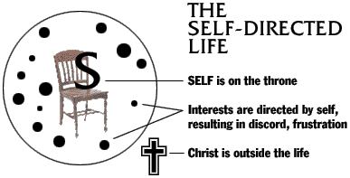 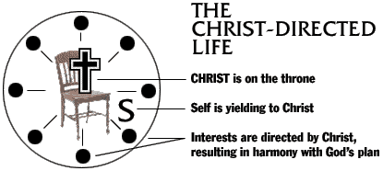

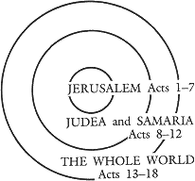Which circle best represent your life? Which circle would you like to have represent your life?